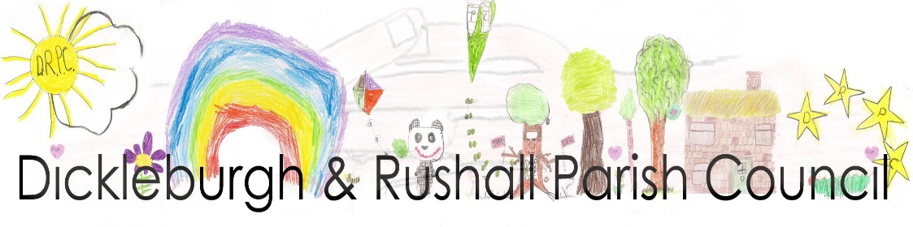
Dear Councillor,
I hereby summon you to the Meeting of the Parish Council, at Dickleburgh & Rushall Village Centre to be held on Monday 17th April 2023 at 7.00pm
Ann Baker

Ann Baker, Clerk to the Council 11th April 2023

AGENDA

Members of the Public are welcome to the meeting. At the start of the meeting fifteen minutes will be available to members of the public to make comments on matters listed on this agenda which may help the councillors with their decision making process.

- To consider accepting apologies for absence
- To receive & update any declarations of pecuniary and other interests from members on any item to be discussed
- To approve the minutes of the last meeting held on 13th March 2023
- To receive the Monthly Financial Report from the RFO including notification of payments made over the last month, to take any necessary actions:
- To approve the payments & receipts
- Appointment of Internal Auditor & preparation for External Audit
- A report on the advice received regarding the Caretaker

The press and public are invited to attend the meeting
Please contact Clerk to the Council, Ann Baker 01379 742937 or email: clerk@dickleburghandrushallpc.org.uk

DICKLEBURGH AND RUSHALL ANNUAL PARISH MEETING
Monday 17th April, 7.30pm

Agenda
- Welcome from the Chair
- A short presentation from La Ronde-Wright, followed by a question answer session
- To approve the Annual Report from 2022 and receive the Annual Report 2023 from the Chair of Dickleburgh & Rushall Parish Council
- To receive an overview of life at SNC from Dist. Cllr. C. Hudson, with short question/answer session
- A short report from The Otter Trust, followed by any queries/interests
- Short report on the Neighbourhood Plan Reg. 14 consultation
- A session from the Waveney Volunteers for Nature, with Q & A
- The Public’s opportunity to raise issues within the two Villages
- Chair’s closing remarks and thanks
Followed by Refreshments

