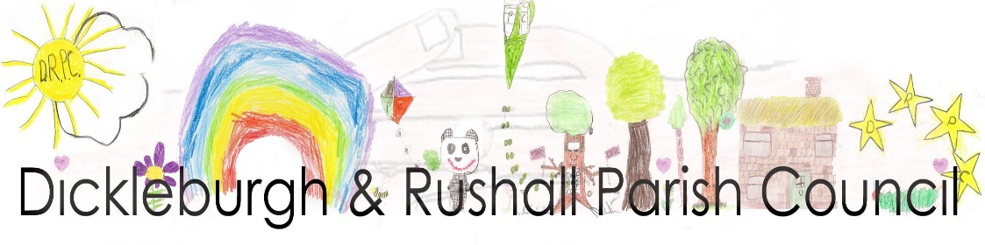
Dear Councillor

I hereby summon you to the Annual Meeting of the Parish Council, at Dickleburgh & Rushall Village Centre to be held on Monday 15th May 2023 at 7.00pm
Ann Baker
Ann Baker, Clerk to the Council 10th May 2023

AGENDA
Members of the Public are welcome to the meeting. At the start of the meeting fifteen minutes will be available to members of the public to make comments on matters listed on this agenda which may help the councillors with their decision making process.
- To elect a Chair of the Parish Council & sign the Declaration of Acceptance
- To elect a Vice-Chair & sign the Declaration of Acceptance
- To consider accepting apologies for absence
- To receive & update any declarations of pecuniary and other interests from members on any item to be discussed
- Adjournment of the meeting for Public participation, County & Dist. Cllrs. reports
- To receive the Annual Report from the Chair
- Approval of the General Power of Competence from 2023 – 2027
- To set a date for the next Annual Parish Council Meeting in 2024
- To approve the minutes of the last meeting held on 17th April 2023
- To note matters arising from the minutes of the last meeting & meeting on 13th March – for information purposes only:
- The Half Moon/Community Asset (min.163b)
- Fallen tree, Lonely Road [min.167(iii)]
- Allotment update (min.172)
- Police entering a residence
- To receive the Monthly Financial Report from the RFO including notification of payments made over the last month:
- To approve the payments & receipts
- To approve a grant application from Waveney Volunteers for Nature (WVN)
- Approval of the AGAR Part 3 Section 1 ‘Annual Governance Statements for 2022 – 2023’
- Approval of the AGAR Part 3, Section ‘Accounting Statements for 2022-2023’
- To approve the ‘Regular Payments, not separately approved for the year 2023 – 2024
- To note the S137 allowance for 2023 – 2024 has been set as £9.93 per resident
- To receive a short update on the Reg. 14 Consultation, Neighbourhood Plan & take any actions
- Planning Applications as received from South Norfolk Council incl.:
- Planning Application 2023/
- To consider any applications which may have been received prior to the meeting & of which Councillors have been previously advised
- To receive consultees reports of planning decisions made by SNC
- To receive a short report on the Coronation event.
- Highways & PROW reports & to take any necessary actions: (i) parking on The Street (ii) Highway Rangers visit (iii) update on Ipswich Rd. safe area – halted due to Barry Duffin’s death (iv) NPLaw - Order for 20mph on Poppy Grove
- Playing Field reports & take any necessary actions:
- To note receipt of the monthly play area inspections
- Zip-wire quotes
- Petanque update
- To receive matters of information from Councillors
- To receive items for the next agenda and confirm the date of the next meeting.

The press and public are invited to attend the meeting
Please contact Clerk to the Council, Ann Baker 01379 742937 or email: clerkdrpc@yahoo.co.uk

